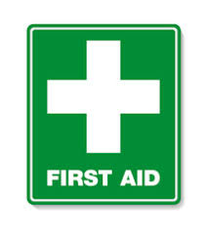
Paediatric First Aiders in EYFS

Mrs Fox Miss Weaver
(January 2024) (January 2024)

Miss Priami
(September 2025)

The above staff hold a current Paediatric First Aid (PFA) certificate

