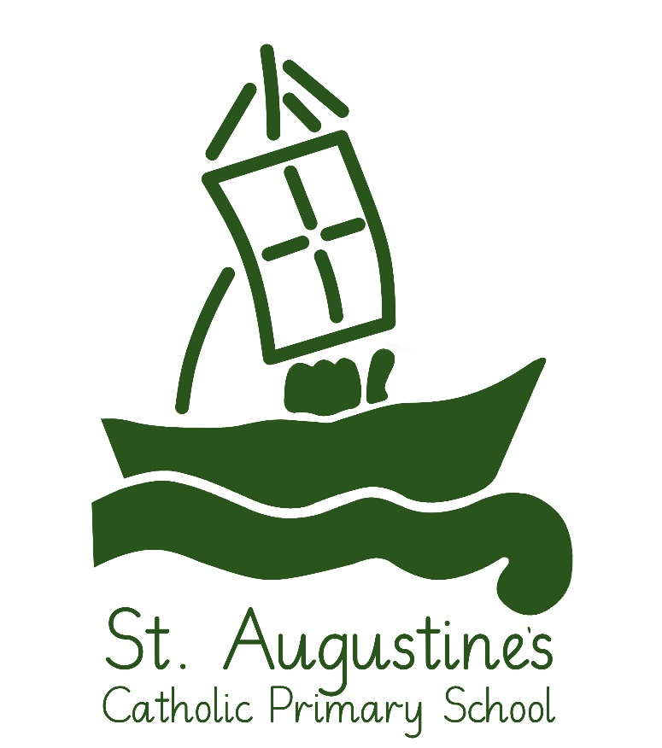

“Hand in hand, we listen to God’s call, we learn from God’s word and we share in God’s love through service”

Behaviour Policy

St. Augustine’s Catholic Primary School

Behaviour Policy

At St. Augustine’s school we believe that every person is made in the image of God. Therefore, every person is of infinite value.

This policy stems from Catholic teaching in the light of the Gospel. Staff will base discipline on forgiveness, encouraging the attitude “I can change” and beginning every day as a “new day”. The school recognises that all pupils are unique and have different experiences that they bring to school. In any situation arising as a result of the recent pandemic, the school will however have to ensure that the health and safety of those children and adults in school is the primary concern and therefore any behaviours that deliberately put that safety at risk will result in the child being sent home.

Aims
- To enable the children to be members of a school community rooted in the teaching of the Gospel.

- To recognise the necessity for respect, honesty, fairness, courtesy and forgiveness.

- To develop in pupils a sense of self-discipline and an appropriate degree of responsibility for their own actions.

- To enable children to know and understand the boundaries of acceptable behaviour and the consequences which follow if these boundaries are breeched.

- To enable the children to be safe and happy.

- To encourage the children to develop a responsible and independent attitude towards learning.

- To respond to any arising pandemic situation in a responsible, age-appropriate way and adhere to the rules established to keep all children and adults on site as safe as possible.

Expectations of Staff
All staff and visitors to the school should act as good role models both in their dealings with pupils and with each other, as their example has an important influence on the children.

All staff:
- Will (where necessary) adhere to the rules as laid out in the Covid-19: Operational Risk Assessment
- Will emphasise the positive.
- Will deal with all incidents in a calm manner
- Must know and value the children as individuals and take their unique circumstances into consideration
- Will maintain positive relationships with all stake holders.
- Will listen to pupils
- Will deal with all incidents fairly so that all pupils can give their view

Expectations of pupils
We have an agreed set of rules that all children are expected to adhere to from Nursery through to Y6 and they are:

Be respectful
Be kind
Be honest
Be safe
Be all we can be!

These rules should be displayed in every classroom and shared area.

Traffic Light System
In all classrooms there is a set of traffic lights on display. All pupils start the day on the green traffic light. If they adhere to the agreed rules, they stay on green and can move up the traffic lights to silver and gold as a reward for their best efforts and behaviour beyond what is expected. If they end the day on silver or gold, they earn extra house points.

Rewards and Recognition

School House System
The children are divided into four houses named after the Patron Saints of England, Ireland, Scotland and Wales. Points are allocated, in multiples of 5, by all members of staff for being a good role model in work, play and attitude around the school. Points can also be awarded to children for being good ambassadors of the school at public events. Points are collated and celebrated at assembly. The points will be shared with parents via the weekly newsletter. The house with the most points at the end of each term are declared the winners. The reward is to choose a treat for an afternoon. The House with the highest total at the end of the year wins the ‘House Cup’.

Brilliant Certificates
Early Years - Y6 will be awarded certificates of brilliance in the Friday Gifts from God assembly. Each class teacher will select a pupil to be awarded a certificate from a range of age-appropriate options e.g. Brilliant Handwriting, Brilliant Manners etc.

Children will also be awarded a range of certificates for demonstrating the school virtues and contributing to Catholic Social Teaching principles.

Sanctions

Whilst good behaviour is always an expectation of all children, we know that there will be occasions when children fall short of these expectations. The ways in which children fall short can look very different. We have identified the stages of behaviour that do not meet these expectations.

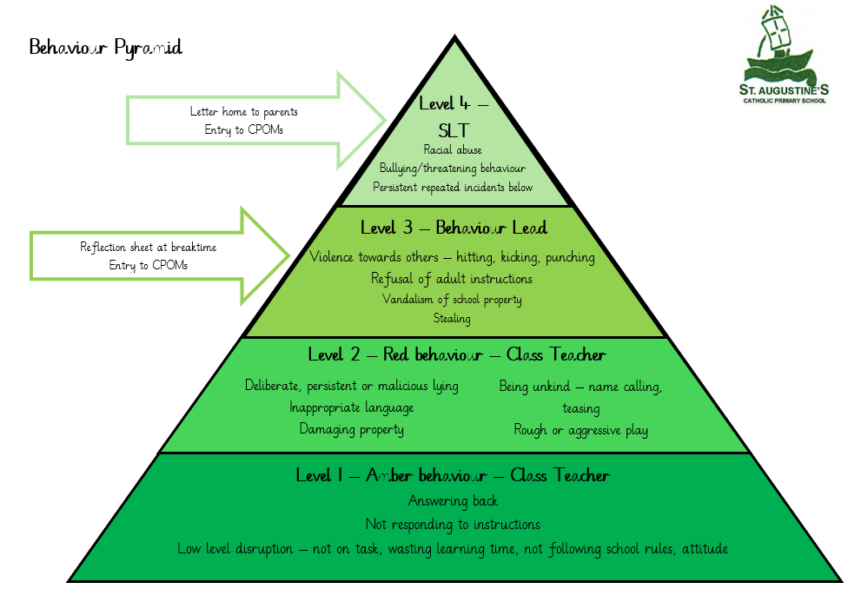

Children who move to amber miss 5 minutes of their next available playtime and should be recorded on the class sheet.
Children who move to red miss 10 minutes of their next available playtime and should be recorded on the class sheet.

Any child who is moved to the red traffic light consistently will be brought to the attention of the Senior Leadership Team.

Behaviours that bypass the traffic light system

- Violence towards others – hitting, kicking, punching
- Defiance - Refusal of adult instructions
- Vandalism of school property
- Stealing
- Bullying/threatening behaviour/language
- Persistent repeated incidents below
- Racial, sexist, homophobic or peer-on-peer abuse will be reported to governors via safeguarding report)

Unfortunately, if a child has already received several reminders about their actions in class and around the school during a half term, parents will be notified with a letter. The child’s behaviour will then be monitored and parents will be notified of the next steps. Parents will be contacted if no active improvements are made. Ann appointment will be made to discuss a behaviour plan for the child. Support for improving this behaviour will then be planned, and this could lead to actions such as; a reduced timetable, provision away from the main classroom, etc. All of this behaviour will be recorded on CPOMs.
If a child is behaving as described in the final bullet point, it will result in a meeting with parents immediately to agree an individual risk assessment and plan of action for the child.

Behaviour outside school
Certain behaviour, even if not on school premises, can result in action being taken by the school. Examples of this would be: the use of social media to intimidate or bully pupils in school or damaging property in the school area whilst travelling to or from school. If the school is made aware of such behaviour, it will take appropriate action. Parents will always be informed of such behaviour and if the behaviour warrants it, the police may be involved.

Exclusions
Internal
There may be times, decided on by the Headteacher, Deputy Head or Assistant Head, where an internal exclusion is applied. This could happen as the result of repeated disruption to other children learning or as the result of physical intimidation to a pupil or member of staff.

External
Repeated poor behaviour over a period of weeks that has been through all previous stages, can then result in a fixed term exclusion. There are, on rare occasions, behaviours that are so unacceptable an immediate exclusion would be warranted. This can only be decided by the Headteacher or in her absence the deputy headteacher or assistant headteacher.
If a child’s behaviour has been poor but does not yet warrant an exclusion, other sanctions may be applied. This may include not going on trips or not being allowed to represent the school in sporting fixtures. These decisions will be made by a senior member of staff and based on the premise that allowing the child to attend could bring the reputation of the school into disrepute.

Emotional and Behavioural Difficulties and Special Needs
There are some children in school who have specific needs that may affect their behaviour. For such children the behaviour policy structure may not work. If this is the case, specific arrangements will be put in place to support the pupils. There is a Calm Room within school that children can access for periods of ‘time out’. This support and the non-negotiable expectations will be decided on an individual basis with the parents/carers and the Leadership Team. This may also involve an individual risk assessment for the child if their behaviour puts others at risk of transmitting COVID.

Working In Partnership with parents/carers
When their child starts at St Augustine’s, all parents are asked to sign our Home/School agreement which outlines what we expect of children with regards to behaviour and what they can expect from us.

Parent/carer conversations will take place in the Autumn and Spring terms where behaviour is discussed, and parents/carers have the opportunity to raise concerns.

Termly reports are sent to parents which also comment on behaviour.

Early intervention-working with parents towards improving aspects of behaviour is helpful in building relationships with a family so that the parents/carers do not feel that the school contacts them only when the child is in trouble.

A member of SLT should be informed if parents/carers need to be contacted by telephone regarding behaviour and this should be recorded on CPOMs to ensure that concerns are evidenced.

Discussions regarding children’s behaviour should not take place on the playground or in earshot of others. Any such discussions should be via telephone or appointment.

After discussions with a member of SLT and/or Inclusion Leader, parents may be involved in record cards, books, use of rewards etc.

Professional Development
Regular INSET will be planned based on monitoring and evaluation of policy and practice.

Team Teach
Most members of staff have attended an accredited positive handling training course (BILD). They have been trained to use holistic de-escalation approaches and safe physical techniques in order to promote socially acceptable behaviours.

