

Supporting Pupils

with Medical Needs Policy
To be approved: H&S Committe Meeting
Review: Annually

Head Teacher’s signature: Governor’s signature:
Date | Amendment | Signed
September 2018 | Names of First aiders
November 2018 | Names of First aiders  Updated Administration of medicines and consent form.
January 2019 | Names of First aiders
July 2019 | Names of First aiders
July 2020 | Covid 19  Updated insurance details  Telephone call to inform parents if replacement medication is required  Medical administration form to be emailed where possible Communal epipen and inhaler now located in first aid cupboard in photocopying room  Medical administration form updated
July 2021 | Names of first aiders
July 2022 | Names of first aiders
May 2023 | Names of first aiders
July 2023 | Annual review
July 2024 | Annual review

St. Augustine’s Catholic Primary School Supporting Pupils with Medical Needs policy Definition
Pupils’ medical needs may be broadly summarised as being of two types:
- Short-term, affecting their participation in school activities whilst they are on a course of medication.
- Long-term, potentially limiting their access to education and requiring extra care and support.

School Ethos

Schools have a responsibility for the health and safety of pupils in their care. The Health and Safety at Work Act 1974 makes employers responsible for the health and safety of employees and anyone else on the premises. In the case of pupils with special medical needs, the responsibility of the employer is to make sure that safety measures cover the needs of all pupils at the school. This may mean making special arrangements for particular pupils so that they can access their full and equal entitlement to all aspects of the curriculum. In this case, individual procedures may be required. St. Augustine’s Catholic Primary School is responsible for making sure that relevant staff know about and are, if necessary, trained to provide any additional support that pupils with medical conditions (long or short term) may need.

The Children and Families Act 2014 places a duty on schools to make arrangements for children with medical conditions. Pupils with medical conditions have the same right of admission to school as other children and cannot be refused admission or excluded from school on medical grounds alone. However, teachers and other school staff in charge of pupils have a common law duty to act ‘in loco parentis’ and must ensure the safety of all pupils in their care.
The prime responsibility for a child's health lies with the parent, who is responsible for the child's medication, and must supply the school with all relevant information needed in order for proficient care to be given to the child. The school takes advice and guidance from a range of sources, including the School Nurse, Health professionals and the child’s GP in addition to the information provided by parents in the first instance. This enables us to ensure we assess and manage risk and minimise disruption to the learning of the child and others who may be affected, for example, other children in the class.

Our Aims

  - To support pupils with medical conditions, so that they have full access to education, including physical education and educational visits
  - To ensure that school staff involved in the care of children with medical needs are fully informed and adequately trained by a professional in order to administer support or prescribed medication
  - To comply fully with the Equality Act 2010 for pupils who may have disabilities or special educational needs.
  - To write, in association with healthcare professionals if deemed necessary, Individual Healthcare Plans where necessary
  - To respond sensitively, discreetly and quickly to situations where a child with a medical condition requires support
  - To keep, monitor and review appropriate records

Unacceptable Practice

While school staff will use their professional discretion in supporting individual pupils, it is unacceptable to:

  - Prevent children from accessing their medication, whether this be prescribed or non-prescribed medication
  - Assume every child with the same condition requires the same treatment
  - Ignore the views of the child or their parents / carers; ignore medical advice
  - Prevent children with medical conditions accessing the full curriculum, unless specified in their Individual Healthcare plan
  - Penalise children for their attendance record where this is related to a medical condition
  - Prevent children from eating, drinking or taking toilet breaks where this is part of effective management of their condition
  - Require parents to administer medicine (unless training is required for staff before they can administer the medicine) where this interrupts their working day
  - Require parents to accompany their child with a medical condition on a school trip as a condition of that child taking part

Entitlement

St. Augustine’s Catholic Primary School provides full access to the curriculum for every child wherever possible. We believe that pupils with medical needs have equal entitlement and must receive necessary care and support so that they can take advantage of this. However, we also recognise that employees have rights in relation to supporting pupils with medical needs, as follows:
Employees may:

  - Choose whether or not they wish to be involved
  - Receive appropriate training
  - Work to clear guidelines
  - Bring to the attention of the Senior Leadership Team any concern or matter relating to the support of pupils with medical conditions

Expectations

It is expected that:

  - Parents will inform school of any medical condition which affects their child.
  - Parents will supply school with appropriately prescribed medication, where the dosage information and regime is clearly printed by a pharmacy on the container
  - Parents will ensure that medicines to be given in school are in date and clearly labelled
  - Parents will co-operate in training their children to self-administer medicine if this is appropriate, and that staff members will only be involved if this is not possible
  - Medical professionals involved in the care of children with medical needs will fully inform staff beforehand of the child’s condition, its management and implications for the school life of that individual
  - St. Augustine’s will ensure that, where appropriate, children are involved in discussing the management and administration of their medicines and are able to access and administer their medicine if this is part of their Individual Healthcare plan (for example, an inhaler)
  - School staff will check that medication is in date half termly and let parents know when the medication is running low via a telephone call.

  - School staff will liaise, as necessary, with healthcare professionals and services in order to access the most up-to- date advice about a pupil’s medical needs and will seek support and training in the interests of the pupil.
  - Transitional arrangements between schools will be completed in such a way that we will ensure full disclosure of relevant medical information, Healthcare plans and support needed in good time for the child’s receiving school to adequately prepare
  - Individual Healthcare plans will be written, monitored and reviewed regularly and will include the views and wishes of the child and parent in addition to the advice of relevant medical professionals, if necessary.

Procedure

The Governing Body of St. Augustine’s ensures that an appropriate level of insurance is in place and reflects the level of risk presented by children with medical conditions. See Employers’ Liability Insurance policy KSC-242102-8473 with Zurich Insurance, including Health and Safety and Employment support.

Information

Children with serious medical conditions will have their photo and a brief description of condition, along with any other necessary information in the first aid area (locked in cupboard), in the office in a folder kept securely and, in their classrooms, (in first aid tray).
Children with medical conditions which may require emergency attention, e.g., epilepsy or diabetes, will have their names and an Individual Healthcare Plan easily accessible in their classroom and school office; ensuring that all adults dealing with the child will have their attention drawn to this information.
Information about children with allergies to any types of food is shared with the catering staff so that school meals are prepared accurately. Some different school meals are provided for children who are coeliac to ensure that the dinner will meet their tolerance levels. All children with allergies and intolerances have a lanyard outlining their allergy/intolerance which they wear when collecting and eating their school lunch.
The Individual Healthcare Plan is developed with the pupil (where appropriate), parent, school staff, specialist nurse (where appropriate) and relevant healthcare services (where appropriate).
All other medical conditions will be noted from children’s Arbor records and this information will be provided to class teachers and support staff annually unless there is a change to a child in their class and then it will be updated promptly.

In an emergency

In a medical emergency, a sufficient number of staff have been appropriately trained to administer emergency paediatric first aid if necessary.
If an ambulance needs to be called, staff will:

  - Outline the full condition and how it occurred
  - Give details regarding the child’s date of birth, address, parents’ names and any known medical conditions.
Children will be accompanied to hospital by a member of staff if this is deemed appropriate. Staff cars should not be used for this purpose. Parents must always be called in a medical emergency, but do not need to be present for a child to be taken to hospital.

Administration of medicines

Only essential medicines will be administered during the school day. These will be only those prescribed by a doctor. Parents must submit a written permission slip (see appendix 2) before any medicine is administered. Where possible, this will be sent and returned via email. Medicines to be given during the school day must be in their original container. Controlled drugs can also be administered, subject to all other conditions as described in the Policy.
Essential medicines will be administered on educational visits, subject to the conditions above. A risk assessment may be needed before the visit takes place. Staff supervising the visit will be responsible for safe storage and administration of the medicine during the visit.
Medicines will normally be administered by the child’s teacher or teaching assistant with another adult present. Before administering any medicine, staff must check that the medicine belongs to the child, must check that the dosage they are giving is correct, and that written permission has been given. Any child refusing to take medicine in school will not be made to do so, and parents will be informed about the dose being missed. All doses administered will be recorded on the record of medicines administered to all children (Form 6- see appendix 1)
All medicines will be stored safely. Medicines needing refrigeration will be stored in the staffroom fridge.

Some medicines (inhalers etc.) will be kept in the child’s classroom in the first aid tray and carried with the children, if appropriate, for ease of access during outside activities. All medicines must be clearly labelled.
When a child uses their asthma inhaler (and this isn’t daily practice), a record of this must be made (see appendix 3) and a letter completed (see appendix 4) and sent out to parents. Inhalers are kept in the child’s classroom. Children have access to these inhalers at all times, though they must inform a member of staff that they are taking a dose. All inhalers are marked with the child’s name. All children with an inhaler must take them on educational visits, however short in duration.
A communal inhaler is kept in the first aid cupboard in the photocopying room. A letter of consent (see appendix 5) will be sent to each child with asthma to obtain written consent for them to use the inhaler. A replacement spacer will be provided by the parent (if possible) if their child uses the inhaler. A written record will be made of the use of the communal inhaler and a letter will be sent to parents to inform them of this.
Epi-pens are kept in classroom cupboards in the first aid tray. In the case of Epi- Pens all staff have access to the box which is clearly labelled and accessible.
A communal epipen is kept in the first aid cupboard in the photocopying room. A letter of consent (see appendix 6) will be sent to each child with an epipen to obtain written consent for them to use the communal epipen (see paragraph below regarding procedures when epipen is administered).
Epi-pen – Any member of staff who has received epi-pen training, can administer an epi-pen in an emergency.

Place child in a position of comfort. Maintain their Airway. REASSURE them. If unconscious, place in recovery position. Ask someone to fetch their EpiPen. Ask someone to telephone for an ambulance. Then inform the parents/carers. Administer EpiPen (see appendix 7). Make a note of time of administration, time of onset of reaction, & events that led up to it. Monitor breathing until ambulance arrives. Give all relevant information to paramedics & also give them the used EpiPen. Do not allow the child to move once the Epipen has been administered. Keep them calm & comfortable until ambulance arrives.

Complaints
Should parents be unhappy with any aspect of their child’s care at St. Augustine’s, they must discuss their concerns with the school. This will be with the child’s class teacher in the first instance, with whom any issues should be managed. If this does not resolve the problem or allay concern, the problem should be brought to the attention of the Senior Leadership Team. In the unlikely event of this not resolving the issue, the parents must make a formal complaint using the school complaints procedure.

Trained Staff

First Aid at Work Qualified Staff
F Turner
M Nixon
J McCarthy
R Ward
A Bennett
H Rowe

Paediatric First Aid Qualified Staff
K Struthers
P Hooker
C Close
N Gibbins
C Carey
H Kelly
S Fox
D Weaver
C Kearns
N Harris
S Sandhu
K Hill
J Wightman

Appendix 1

FORM 6

Record of medicines administered to all children

Name of school/setting ………………………………………………………….. YEAR GROUP

Date | Child’s name | Time | Name of medicine | Dose given | Any reactions | Signature of  staff | Print Name


Appendix 2
ST. AUGUSTINE’S CATHOLIC PRIMARY SCHOOL
Heathcote Street
Coventry, CV6 3BL
Telephone : 024 7659 6988
Headteacher : Miss V. McDonald
E-mail: admin@st-augustines.coventry.sch.uk
headteacher@st-augustines.coventry.sch.uk

ST. AUGUSTINE’S
CATHOLIC PRIMARY SCHOOL

REQUEST FOR ADMINISTRATION OF MEDICINES

My child has been diagnosed as suffering from ................................................................................................

He/she is considered fit for school but requires the following prescribed medicine to be administered during school hours:

Names of medicine ..............................................................................

Could you please administer (dosage) at

. (time)

With effect from (date)

. (date)

The medicine should be administered by mouth / in the ear / nasally

If other please specify: .............................................................................................................................................

I understand that all staff are acting voluntarily in administering medicines and have the right to refuse to administer medication. I understand that the school staff can not undertake to monitor the use of inhalers carried by children, and that the school is not responsible for loss or damage to any medication.

I undertake to update the school with any changes in administration for routine or emergency medication and to maintain and in-date supply of the medication.

Signed by person with legal responsibility for the
young person

Name of signatory: (Please print)

Child's name: (Please print)

-----------------------------------------------------------------------------------------------------------------
Please note the following quotations from the County Code of Practice regarding the administration of medicines at school.
- Children who are acutely ill and require a short course of medication e.g. antibiotics, will normally remain at home until the course is finished. If it is felt by a medication practitioner that the child is fit enough to return to school, the dosage can usually be adjusted so that none is required at lunch- time.

- No medicine should be administered unless clear written instructions to do so have been obtained from the parents or legal guardians and the school has indicated that it is able to do so. It must be understood that all staff are acting voluntarily in administering medicines.
Appendix 3

Record of use of inhaler Class

Name | Date | Time | No. of  puffs | Where /activity  eg. classroom/ PE | Childs  own Inhaler | School  Inhaler | Parent  letter | Given By

Appendix 4
ST. AUGUSTINE’S CATHOLIC PRIMARY SCHOOL
Heathcote Street
Coventry, CV6 3BL
Telephone : 024 7659 6988
Headteacher : Miss V. McDonald
E-mail: admin@st-augustines.coventry.sch.uk
headteacher@st-augustines.coventry.sch.uk

ST. AUGUSTINE’S
CATHOLIC PRIMARY SCHOOL

Notification to parent

Date

Dear parent/guardian of: ………………………………

Your child has had problems with his/her breathing today which has required the use of their own inhaler/school’s emergency inhaler. (delete as appropriate)
Since this may indicate your child’s asthma is not well controlled at this time you are strongly advised to see your own doctor or practice nurse as soon as possible. If your child needs to use their reliever medication 3 times a week or more, seek a medical review.

Date | Time | Number of puffs | Where/Activity (eg. classroom/  PE) | Given By

If your child needed to use the school emergency inhaler, please ensure they have their own labelled inhaler and spacer (if they use one) in school.
If your child is needing to use their reliever inhaler more than 4 hourly, please seek an urgent medical review.

Yours sincerely,

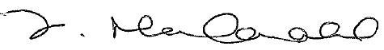

Miss V. McDonald
Headteacher

Appendix 5
ST. AUGUSTINE’S CATHOLIC PRIMARY SCHOOL
Heathcote Street
Coventry, CV6 3BL
Telephone : 024 7659 6988
Headteacher : Miss V. McDonald
E-mail: admin@st-augustines.coventry.sch.uk
headteacher@st-augustines.coventry.sch.uk

ST. AUGUSTINE’S
CATHOLIC PRIMARY SCHOOL
Guidance on the use of emergency salbutamol inhalers in schools 2021
Annex A

CONSENT FORM:
USE OF EMERGENCY SALBUTAMOL INHALER

Child showing symptoms of asthma / having asthma attack
- I can confirm that my child has been diagnosed with asthma / has been prescribed an inhaler [delete as appropriate].

- My child has a working, in-date inhaler, clearly labelled with their name, which they will bring with them to school every day.

- In the event of my child displaying symptoms of asthma, and if their inhaler is not available or is unusable, I consent for my child to receive salbutamol from an emergency inhaler held by the school for such emergencies.

Signed: …………………………………………… Date: ………………………………………………
Name (print)……………………………………………………………………………………… Child’s name: …………………………………………………………………………………… Class: ……………………………………………………………………………………………… Parent’s address and contact details:

Telephone: ……………………………………………………………………………………… E-mail: ……………………………………………………………………………………………

Appendix 5
ST. AUGUSTINE’S CATHOLIC PRIMARY SCHOOL
Heathcote Street
Coventry, CV6 3BL
Telephone : 024 7659 6988
Headteacher : Miss V. McDonald
E-mail: admin@st-augustines.coventry.sch.uk
headteacher@st-augustines.coventry.sch.uk

ST. AUGUSTINE’S
CATHOLIC PRIMARY SCHOOL

Dear Parents / Guardians,

In line with government guidance, we have purchased a Salubtamol Inhaler to be used in an emergency situation only.

Please complete the attached consent form if you agree that your child could use the inhaler if necessary i.e. if they didn't have their inhaler in school.

If you have any questions, please contact me to discuss this further.

Yours faithfully,

Miss V. McDonald
Headteacher

Appendix 6
ST. AUGUSTINE’S CATHOLIC PRIMARY SCHOOL
Heathcote Street
Coventry, CV6 3BL
Telephone : 024 7659 6988
Headteacher : Miss V. McDonald
E-mail: admin@st-augustines.coventry.sch.uk
headteacher@st-augustines.coventry.sch.uk

ST. AUGUSTINE’S
CATHOLIC PRIMARY SCHOOL

Dear Parents / Guardians,

In line with government guidance, we have purchased an EpiPen to be used in an emergency situation only.

Please complete the attached consent form if you agree that your child could use the EpiPen if necessary, i.e., if they didn't have their EpiPen in school.

If you have any questions, please contact me to discuss this further.

Yours faithfully,

Miss V. McDonald
Headteacher


Appendix 7 (PowerPoint slides from

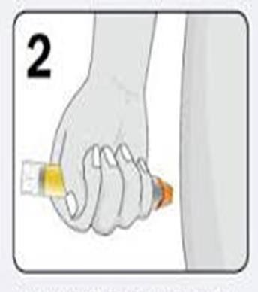
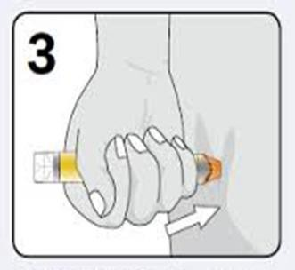

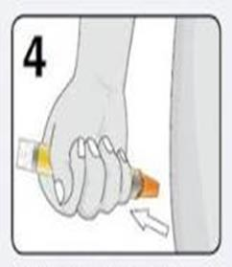
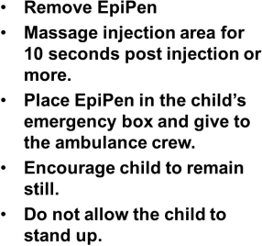
How to use the device (epipen)
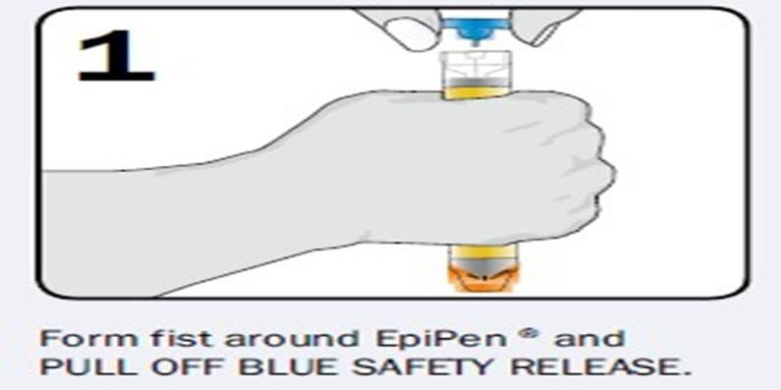

REMEMBER IT IS BETTER TO GIVE THE EPIPEN THAN TO NOT GIVE IT.

IF IN ANY DOUBT ADMINISTER IT.

YOU COULD BE SAVING A CHILD'S LIFE!

