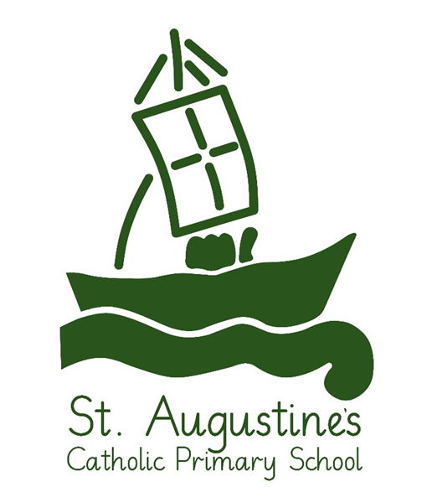

Accessibility Policy

Approved 2024
Review: September 2026

Head Teachers signature:
Governor’s signature:

1. Aims
Schools are required under the Equality Act 2010 to have an accessibility plan. The purpose of the plan is
to:
- Increase the extent to which disabled pupils can participate in the curriculum
- Improve the physical environment of the school to enable disabled pupils to take better advantage of education, benefits, facilities and services provided
- Improve the availability of accessible information to disabled pupils
Our school aims to treat all its pupils fairly and with respect. This involves providing access and opportunities for all pupils without discrimination of any kind.
We are committed to providing an environment that enables full curriculum access that values and includes all pupils, staff, parents and visitors regardless of their education, physical, sensory, social, spiritual, emotional and cultural needs. We are committed to taking positive action in the spirit of the Equality Act 2010 with regard to disability and to developing a culture of inclusion, support and awareness within the school.
The Accessibility Plan will contain relevant and timely actions to:
- increase access to the curriculum for pupils with a disability, expanding the curriculum as necessary to ensure that pupils with a disability are as, equally, prepared for life as are the able-bodied pupils; (If a school fails to do this they are in breach of duties under the Equalities Act 2010); this covers teaching and learning and the wider curriculum of the school such as participation in after-school clubs, leisure and cultural activities or school visits - it also covers the provision of specialist or auxiliary aids and equipment, which may assist these pupils in accessing the curriculum within a reasonable timeframe;
- Improve access to the physical environment of the school, adding specialist facilities as necessary – this covers improvements to the physical environment of the school and physical aids to access education within a reasonable timeframe;
- Improve the delivery of written information to pupils, staff, parents and visitors with disabilities; examples might include handouts, timetables, textbooks and information about the school and school events; the information should be made available in various preferred formats within a reasonable timeframe.
Our school is also committed to ensuring staff are trained in equality issues with reference to the Equality Act 2010, including understanding disability issues.
The school supports any available partnerships to develop and implement the plan. These relationships include the Local Authority and the Holy Cross Catholic Multi Academy Company (MAC)
St. Augustine’s Catholic Primary School is committed to providing premises that are suitable and sufficient for all educational purposes and give access to a broad and balanced curriculum for all students irrespective of special need or disability.
It is a requirement that the school’s accessibility plan is resourced, implemented, reviewed and revised as necessary and reported on annually.
Attached is a set of action plans (Section 3) showing how the school will address the priorities identified in the plan.
The plan must be renewed every three years. The current time frame is 2024- 2026
2. Legislation and guidance
This document meets the requirements of schedule 10 of the Equality Act 2010 and the Department for Education (DfE) guidance for schools on the Equality Act 2010.
The Equality Act 2010 defines an individual as disabled if he or she has a physical or mental impairment that has a ‘substantial’ and ‘long-term’ adverse effect on his or her ability to undertake normal day to day activities.
Under the Special Educational Needs and Disability (SEND) Code of Practice, ‘long-term’ is defined as ‘a year or more’ and ‘substantial’ is defined as ‘more than minor or trivial’. The definition includes sensory impairments such as those affecting sight or hearing, and long-term health conditions such as asthma, diabetes, epilepsy and cancer.
Schools are required to make ‘reasonable adjustments’ for pupils with disabilities under the Equality Act 2010, to alleviate any substantial disadvantage that a disabled pupil faces in comparison with non-disabled pupils. This can include, for example, the provision of an auxiliary aid or adjustments to premises.
This policy complies with our funding agreement and articles of association.
Definitions and Duties
Schools’ duties around accessibility for disabled pupils:
Schools and LAs need to carry out accessibility planning for disabled pupils. Schools must implement accessibility plans which are aimed at:
- increasing the extent to which disabled pupils can participate in the curriculum;
- improving the physical environment of schools to enable disabled pupils to take better advantage of education, benefits, facilities and services provided;
- improving the availability of accessible information to disabled pupils.

3. Action plan
- Improving the Curriculum Areas (increasing the extent to which disabled pupils can participate in the school curriculum.

TARGET | STRATEGY | OUTCOME | TIMEFRAME | ACHIEVEMENT
All extracurricular activities are planned to ensure they are accessible to all children. | Review all out-of-school provision to ensure compliance with legislation | All out-of-school activities will be conducted in an inclusive environment with providers that comply with all current and future legislation. | Ongoing | Increase in access to all school activities for all pupils.
Ensure quality first teaching meets the needs of all children. | Focused teacher planning informed by assessment of individual pupil needs. | Effective support and scaffolding.  Intervention and consolidation provided promptly where necessary. | Ongoing | All pupils make appropriate progress.
To meet the needs of individuals during statutory tests. | Children will be assessed in accordance with regular classroom practice, and additional time, readers, rest breaks, use of equipment etc. will be  applied as needed. | Barriers to learning will be reduced or removed, enabling children to achieve their full potential. | Annually. | Support given where needed to enable all children to have access. Children with concentration difficulties access test in a small group with appropriate rest breaks.  Children with anxiety issues supported with practice for tests and time to talk sessions.
Ensure all children with medical needs have an Individual Healthcare Plan in place. | Liaise with parents to write the Healthcare Plan following medical guidance. | Healthcare plan is up to date and shared with all staff. | At least annually – to be updated when medical needs change | Healthcare Plan in place and highlighted to support the needs of individual children.

2. Improving the Physical Access and Environment

LOCATION | ITEM TO IMPROVE PHYSICAL ACCESS | ACTIVITY | TIMEFRAME
Access to disabled toilet Areas | One toilet in school. | Make sure that facilities are in working order | Ongoing
Ensure pupils have suitable desk workstation in class | An inclined writing ramp may be used to improve access to written materials. | Trial of features for pupils and evaluation as to whether or not these would be useful. | Ongoing
Consider ASD or dyslexia friendly classrooms. | Readily available resources to support pupil needs. | Use of laptop to record writing. Advice specialist services to provide /suggest appropriate resources, e.g.; use of laptop. Teaching assistant and teachers to support responses to written feedback. Access arrangements for statutory assessment for children with SEN/additional needs. | Ongoing

3. Improving the Delivery of Written Information- Accessibility of information for disabled pupils and families
TARGET | STRATEGY | OUTCOME | TIMEFRAME | ACHIEVEMENT
Availability of written materials in alternative formats | The school will make itself aware of the services available through the LA for converting written information into alternative formats. | The school will be able to provide written information in different formats when required for individual purposes | Ongoing | Delivery of information to pupils and parents/carers improved
Make available school prospectus, newsletters and other information in alternative formats. | Review all current school publications and promote the availability in different formats for those that require it. | All school information available for all.  School information published on school website and updated regularly. | Ongoing | Delivery of information to pupils and parents/carers improved

